A Project entitled

**“CAN Bus Prototype”**

Completed at

Government College of Engineering, Karad

(An Autonomous Institute of Govt. of Maharashtra)

for the degree of

BACHELOR OF TECHNOLOGY

in

ELECTRONICS AND TELECOMMUNICATION ENGINEERING

By

Ashish Prabhakar Shinde[21151206]

Suyog Jayavant Kale[21151225]

Rahul Narendra Wankhade[21151261]

Under the Guidance of

Prof. A.S.Shinde



DEPARTMENT OF ELECTRONICS AND TELECOMMUNICATION ENGINEERING

Government College of Engineering, Karad

2023-2024

**Declaration by the Student**

I hereby declare that the thesis entitled **““CAN Bus Prototype”** completed and written by me has not formed earlier the basis for the award of any degree or similar title of this or any other University or examining body.

Further, I declare that I have not violated any of the provisions under the acts of Copyright/Piracy/Cyber/IPR etc. amended from time to time.

**Place: Karad**

**Date:**

**Name of students**

**Ashish Shinde**

**Suyog Kale**

**Rahul Wankhade**

**Guides/Supervisor’s Certificate**

This is to certify that the dissertation entitled **““CAN Bus Prototype”** being submitted herewith for the award of the Degree of Master of Technology in Electronics and Telecommunication Engineering Under the faculty of SCIENCE AND TECHNOLOGY is the result of the original research work completed under my supervision and guidance and to the best of my knowledge and belief the work embodied in this has not formed earlier the basis for the award of any degree or similar title of this or any other University or examining body.

**Place: Karad**

**Date: Prof. A.S.Shinde**

**Research Guide/ Supervisor name of guide**

# Abstract

The Controller Area Network (CAN) bus has become an integral part of modern automotive systems, facilitating seamless communication between various electronic control units (ECUs) within a vehicle. This project aims to explore the implementation and analyze the performance of the CAN bus in the context of automotive applications.

The project begins with an in-depth overview of the CAN bus protocol, highlighting its key features and advantages in providing a robust and efficient communication framework. The focus then shifts to the practical implementation of the CAN bus in a simulated automotive environment, with an emphasis on the integration of ECUs responsible for different functionalities such as engine control, braking, and transmission systems.

Throughout the implementation phase, the project investigates the challenges and considerations involved in designing a reliable and fault-tolerant CAN bus network. The study includes the identification and mitigation of potential issues such as bus arbitration, error handling, and message prioritization. Additionally, the project explores the impact of varying communication loads and network topologies on the overall system performance.

To validate the effectiveness of the implemented CAN bus, the project conducts extensive testing and analysis. Performance metrics such as message latency, throughput, and bus utilization are measured under different operating conditions to assess the robustness and scalability of the system. The findings from these tests provide valuable insights into optimizing the CAN bus network for real-world automotive applications.

# 

# Acknowledgement

I take the opportunity to express our deep sense of gratitude & respect towards all who helped us to complete my project. I sincerely & humbly express my gratefulness to my guide **Prof.A.S.Shinde (Department of Electronics And Telecommunication) Government College of Engineering, Karad** & thanks him for his valuable support, his guidance, encouragement & co-operation without which this project would not be completed. Last but certainly not the least I extend my gratefulness to teaching & nonteaching staff members of Electronics and Telecommunication department & to all our dear friends who have directly or indirectly helped in completion of this project. I also express my sincere thanks to **Prof. Supriya Diwan**, head of department and **Dr. Sanjeev J. Wagh**, Principle for providing me the facilities and inspiration in bringing out this thesis.

**Name of students**

**Ashish Shinde**

**Suyog Kale**

**Rahul Wankhade**

# 

# Table of Contents

Contents

Abstract iv

Acknowledgement v

Table of Contents vi

Chapter 1 Introduction 1-2

1.1 General Information 1-1

1.2 For the Figure 1-2

Chapter 2 Actual Project Work 3-4

Chapter 3 Actual Project Work 4-4

Chapter 4 Applications 5-5

Chapter 5 Summary, Conclusions and Future Scope 6-6

5.1 Summary 6-6

5.2 Observation and Conclusions 6-6

3.3 Future Scope 6-6

References 6-7

# Introduction

## General Information

* It is a multi-master serial communication bus whose basic design specification called for high speed, high noise- immunity and error-detection features
* CAN offers data communication up to 1 Mbit/sec
* The Error Confinement and the Error Detection features make it more reliable in noise-critical environments. In the automotive industries
* Extensive Use: CAN is widely used in automotive applications for tasks like engine control, transmission control, and in-vehicle networking. It's also used in industrial automation, aerospace, and various other fields
* It's a broadcast type of Bus
* No way to send a data specifically to a node by its address or something.
* All devices can hear the transmission
* All nodes will pick up the traffic on the bus
* The CAN standard defines a communication network that links all the nodes connected to a bus and enables them to talk with one another. There may or may not be a central control node, and nodes may be added at any time, even while the network is operating (hot-plugging).

## 

## For the Figure of CAN BUS Nodes

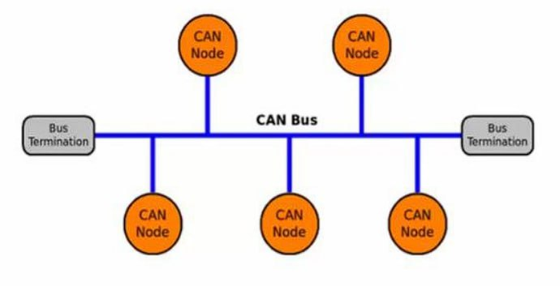

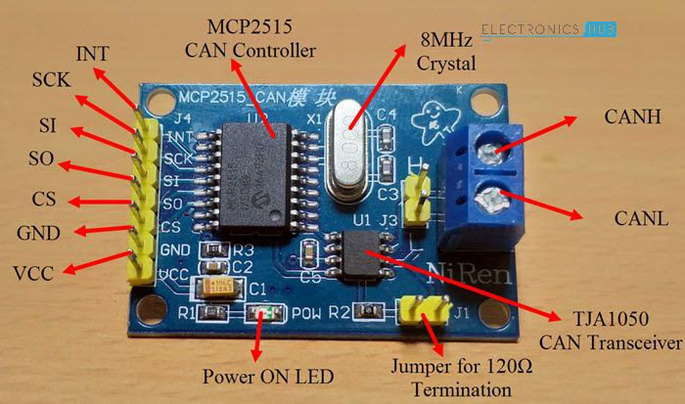

Fig. MCP2515 CAN Bus Controller Module

This particular module is based on MCP2515 CAN Controller IC and TJA1050 CAN Transceiver IC. The MCP2515 IC is a standalone CAN Controller and has an integrated SPI Interface for communication with microcontrollers. Coming to the TJA1050 IC, it acts as an interface between the MCP2515 CAN Controller IC and the Physical CAN Bus.

The board has a 8 MHz Crystal oscillator. Even the 16 MHz version is also available. A jumper can be attached which will give 120ohm Termination. CAN_H & CAN_L are the two screws where wires can be attached over a distance for communicating with other CAN Module

# 

# Actual Project Work

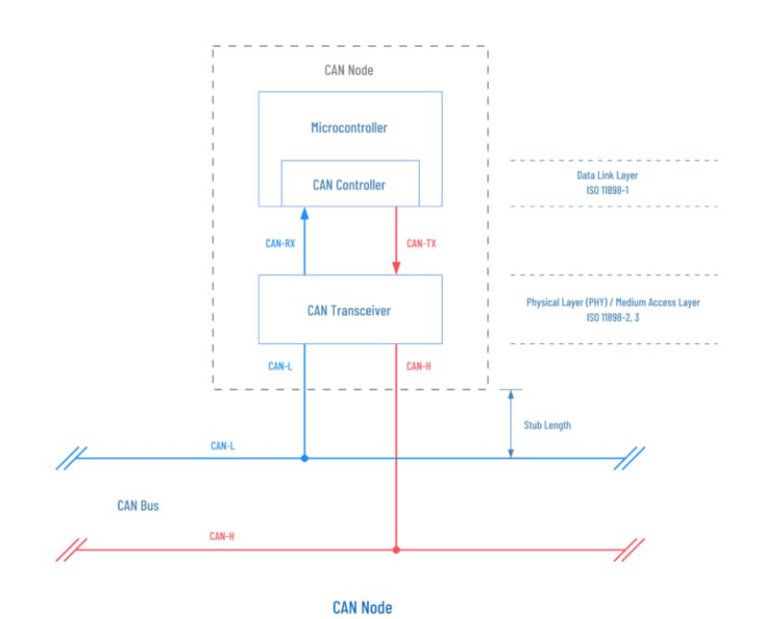1.Topology:

* Bus Architecture: The CAN bus typically employs a bus topology, where multiple ECUs are connected to a shared communication line or bus.
* Two-Wire System: CAN uses a two-wire system — a CAN High (CAN_H) and a CAN Low (CAN_L) wire — for communication between nodes.

2.Message Transmission:

* Frame Structure: Data on the CAN bus is transmitted in frames. There are two main types of frames: Data frames, which carry application data, and Remote frames, which are used for request-response scenarios.
* Identifier: Each frame has a unique identifier that determines its priority on the bus. Lower identifier values indicate higher priority.

3.Arbitration:

* Bitwise Arbitration: Multiple ECUs may attempt to transmit messages simultaneously. CAN uses bitwise arbitration, where the ECU with the lowest identifier has the highest priority and gains control of the bus.
* Collision Resolution: If two ECUs start transmitting at the same time, the one with the lower identifier continues transmitting, while the other backs off and retries.

4.Acknowledgment:

* Acknowledgment Bit: After successfully transmitting a message, the sender monitors the bus for an acknowledgment bit. If an acknowledgment is received, the sender knows the message was received correctly.
* Error Handling: If no acknowledgment is received, the sender assumes an error occurred and initiates error-handling procedures.

5.Synchronization:

* Bit Timing: All nodes on the CAN bus synchronize their internal clocks based on the timing information specified in the transmitted messages. This ensures accurate bit timing for communication.
* Clock Synchronization: Nodes use the edges of the transmitted bits to synchronize their clocks.

6.Error Detection and Handling:

* Cyclic Redundancy Check (CRC): Each CAN message includes a CRC for error detection. If a receiving node detects an error, it can request retransmission.
* Error Frames: Special error frames are transmitted to indicate errors on the bus. ECUs can take appropriate actions based on these error frames.

7.Real-Time Communication:

* Deterministic Timing: CAN provides deterministic and predictable timing for message transmission, making it suitable for real-time applications.
* Priority-Based: The priority-based arbitration mechanism ensures that critical messages are transmitted with higher priority.

8.Termination:

* Termination Resistors: To prevent signal reflections and maintain signal integrity, the CAN bus usually includes termination resistors at both ends.

9.Bus Off and Recovery:

* Fault Handling: If a node experiences too many errors, it may go into a "Bus Off" state and disconnect from the bus to avoid disrupting communication.
* Automatic Recovery: Nodes in the Bus Off state can automatically attempt to rejoin the bus after a specified time.

10.Multi-Master System:

* Distributed Control: CAN supports a multi-master system where any node can initiate communication. This distributed control architecture enhances system reliability.

**Chapter 3**

**Actual Project Work**

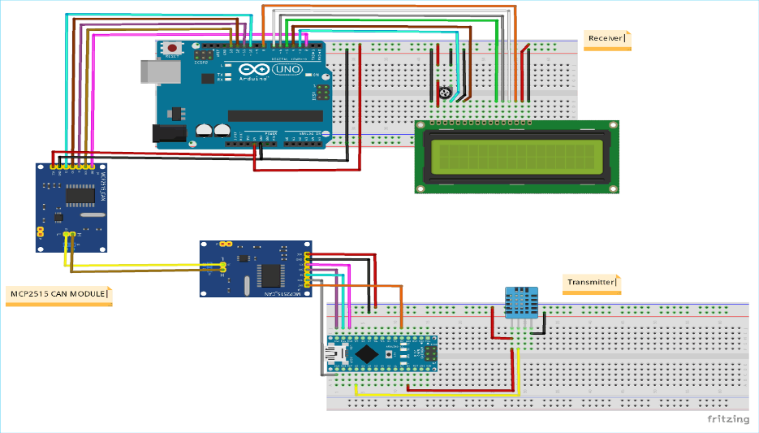

**Prerequisites & Equipment:**

We need the following:

1. Two Arduino Board.
2. LCD and DHT11 Sensor.
3. Arduino IDE for the programming.
4. Two CAN Tranciever(MCP2515 & TJA1050).

This project is designed to read Humidity and Temperature using DHT11 And transmitting by CAN protocol implementation. The Humidity and Temperature changes are measured by the ADC and transmitted to the other node using the CAN Bus and the data is received at the other node and displayed in an LCD.

It is assumed that the reader has gone through the Getting started with CAN interface with Arduino and done all the things discussed in it.

# Chapter 4

# Applications

* The CAN bus is a robust and widely used communication protocol designed for reliable data transmission in real-time environments.
* Automotive Systems:
* Engine control units (ECUs): CAN bus is commonly used for communication between various ECUs in a vehicle, such as the engine control unit, transmission control unit, and more.
* Infotainment systems: Prototype connectivity between multimedia systems, GPS, and other in-car entertainment components.
* Advanced driver assistance systems (ADAS): Implement communication between sensors, cameras, and control units for features like adaptive cruise control and lane-keeping assistance.
* Industrial Automation:
* Factory automation: Use CAN bus for communication between programmable logic controllers (PLCs), sensors, actuators, and other industrial devices in manufacturing environments.
* Marine and Aerospace:
* Marine applications , Aerospace systems.
* Agricultural Machinery , Medical Devices , Research and Development

# Chapter 5

# Summary, Conclusions and Future Scope

## 5.1Summary

The CAN Bus Project aimed to implement and analyze the Controller Area Network (CAN) bus in the context of specific application or industry, e.g., automotive systems. The project focused on data transmission.

## 5.2Observation and Conclusions

* In conclusion, a Controller Area Network (CAN) bus prototype is a valuable tool with a wide range of applications across various industries. It provides a reliable and robust means of real-time communication between electronic components and devices, making it ideal for automotive, industrial, and even home automation systems. Whether you're developing cutting-edge automotive features, optimizing industrial processes, or creating smart home solutions, a CAN bus prototype allows you to design, test, and refine your communication systems effectively.
* The versatility of CAN bus technology is a key advantage, as it can be adapted to suit the specific needs of your project. From engine control units in vehicles to factory automation in manufacturing plants, the potential applications are vast.
* In a rapidly evolving technological landscape, CAN bus prototypes play a crucial role in shaping the future of automotive, industrial, and automation systems, ensuring they operate efficiently, reliably, and securely.

## 5.3Future Scope

* Recommendations for future improvements or expansions in the CAN bus network.
* Suggestions for further research or developments based on the project's outcomes